BCDBALP – How to Check BCD Type

Shows BCD agreement.

Mandatory Fields:

Populate the following fields.

SCREEN: 10
ACTION: DS

Click Enter. Enter the BCD Number. Click Enter.

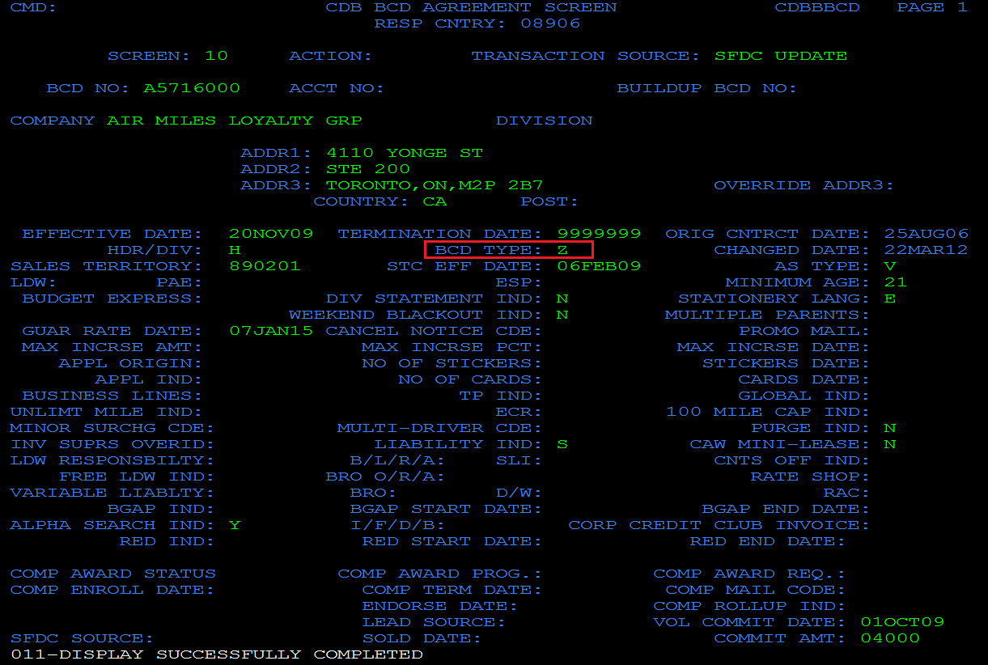

BCD Type | Description
A | A-GroupAssociation
C | C-Corporate
F | F-FieldAssociation
G | G-Government
J | J-LeisurePass
K | K-CompetitiveAWD
M | M-Marketing
S | S-Telesales_CorpAWD
T | T-Telesales_Avischargecard
Z | Z-Touroverride

